Newby and Scalby Primary School

A guide to coming back to school for Y6 pupils and their parents

General information:
- We are really looking forward to welcoming you back to school. Teachers have made sure that you will be with some of your friends. One of the first things that you will be doing is deciding on a group name for everyone in your room and decorating the walls with pictures that make the space your own.
This is because things look a bit bare as we need to keep all the surfaces clear for easy cleaning.
- Although the room that you will work in will look very different, the adults that work with you will all be as friendly and helpful as ever. (It’s very different for them too.)
- In the first week, Class 13 will attend in the mornings 9am-11.30am
Class 14 will attend in the afternoons 1pm-3.30pm
The half days are so that you can get used to working in a different way to before
and to help us to get it right for you.
- In the second Week, Class 13 will attend from 9.00am-3pm
Class 14 will attend from 9.30am-3.30pm.
The staggered start times are so that we avoid having lots of people arriving at school at once.
- The behaviour policy has been changed to make sure that children do not make it unsafe for others.
Hand washing, staying two metres apart (including on your way to school) and not turning round
in your seat are all things that you could practice how to do before you return to school.
- Please prepare yourself for standing in queues where everyone is 2 metres apart while waiting to wash hands, go to the toilets or move around the building.
This is because we are trying to make sure that germs don’t spread between people.
- You need to know that if anyone in your group shows signs of having caught Covid-19 we will have to ask you to stay away from school until everyone is checked. Anyone who is ill cannot come to school and if you become ill during the day, you will be taken home.

Before school
- Please wear uniform if possible. Shoes or trainers that you can run around safely in are important.
Don’t worry if your parents want to wash your uniform more often than normal or if it is too small.
- Please bring a water bottle, any medication, a packed lunch and a coat but nothing else.
We will provide you with all of the equipment that you need so that there is
less chance of bringing germs into school or taking them home.
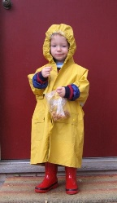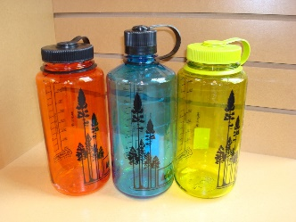
- Please arrange for an adult to drop you off and collect you from school
This is because they will be able to help you to practise staying two metres
away from others (especially your friends who you haven’t seen for a while).
- Please enter the school playground through the normal KS2 entrance gates. A member of staff will show you where to wait. This will be 2 metres from anyone else.
- Your group leader will tell you everything that you need to know before you enter the building.

In the building
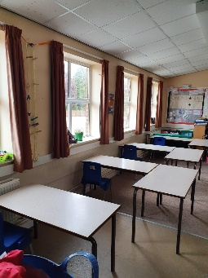
- Lots of rooms have been closed off.
This is to help our cleaners to focus on the areas that we need to use.
- Each group will have their own room to work in and every child will have his/her own desk that will not be shared with anyone else.
This is to make sure that we prevent the spread of germs and don’t have to close
the whole school if someone gets ill.

The daily routine
- Lessons will be the same as the children will be doing at home.
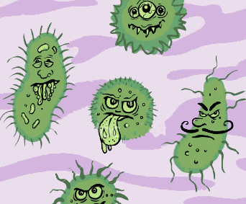
- You will do all your work at your desk on your own with an adult there to help you.
This is to make sure that we don’t spread germs.
- Each group will have separate exercise and toilet breaks to other groups and activities will be provided that help you to stay 2 metres from other people.
This is to make sure that we don’t spread germs.
- From the second week, you will eat lunch at your desk and you will have an exercise session with activities afterwards.
This is to make sure that we don’t spread germs and the room will be cleaned while you are exercising.
- At the end of the day you will meet your parent on the playground and leave through the single gate by the bottom playground.
This is because there will be a one-way system in place to help people to stay 2 metres apart.

Hygiene
- All rooms will have spray disinfectant, cloths and gloves for the adults to use as well as sinks, soap, tissues and bins for everyone to use.
This is to make sure that we don’t spread germs.
- Everyone will be encouraged to “Catch it, bin it, kill it” for coughs and sneezes and to cough or sneeze into their elbow if they haven’t got a tissue. The “dab cough”.
This is to make sure that we don’t spread germs.
- If you are unwell during the day a member of staff may put on an apron, a mask, gloves and goggles and take you to a room to wait for you to be taken home. We will show you this on the first day so that it doesn’t shock you if it is needed.
This is to make sure that we don’t spread germs.

