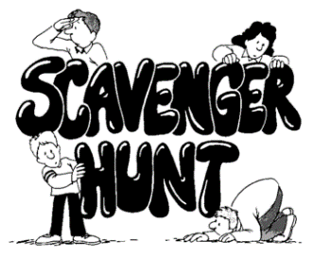
Newby and Scalby Primary School
Summer Challenge 2020
Scavenger Hunt
Please note that the scavenger hunt will be used as the starting point for work in September. Please try to collect as many of the items as possible and take a photograph of them all if you can. Glue the photograph to the back.
The Challenge | Write or draw what you found
Something left over from before lockdown
Something that costs less than £1
Something that is really shiny
Something that no-one else in the class will have
Something that is the shape of a triangle
Something that makes you very happy
Something that has no corners
Something that you found down the side of the sofa/chair

Something that you’d like to get rid of
Something that makes a nice noise
Something that you can re-use
Something that smells nice

OPTIONAL EXTRA – Enjoy a book from Newby and Scalby Library’s “Select and Collect” scheme
Mr Kirkham-Knowles (Scavenger-in-Chief)
Please bring this checklist on the first day of term.

